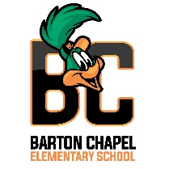 **Hello Parents!

I am Dr. Freeman, your child's 4th grade Science and Social Studies Teacher at Barton Chapel Elementary School for the 2024-2025 school year and I am super excited to work with your son/daughter this year! We are off to a great start and there is no stopping us now! I have high expectations for our scholars, and being a veteran educator for over twenty-two years, I know together we can and we will accomplish and exceed our goals as a class, grade level, and school.

A few quick reminders:

* Class Dojo will be my first line of communication; however, if you need to contact me, my email is:

**[robindi@richmond.k12.ga.us](mailto:robindi@richmond.k12.ga.us)**

* Homework will be assigned Monday-Thursday’s. Tests on Friday’s. Please check Class Dojo and your child’s Agenda nightly for assignments and important messages. (Initial nightly)

* My planning time is 2:00 – 2:45 pm.
* Any transportation changes must be done in writing. (note from parent with signature).

I look forward to having an awesome school year! Again, welcome and thank you for being a part of the Barton Chapel Family!

Thank you,

Dr. Dianesha Robinson-Freeman

4th Grade Science & Social Studies Teacher

Barton Chapel Elementary School